**Advanced Learning Algorithms**

Steps of Model Training in Neural Networks

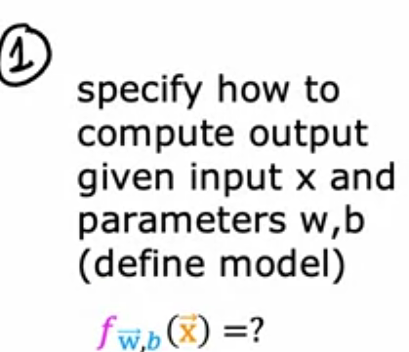

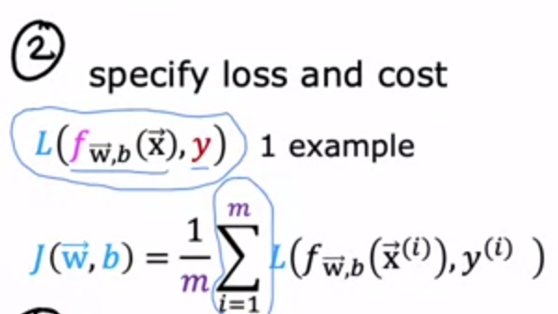

Binary cross entropy loss function is the function used in logistic regression.



___

Activation Functions

They are used in the output layer of NN

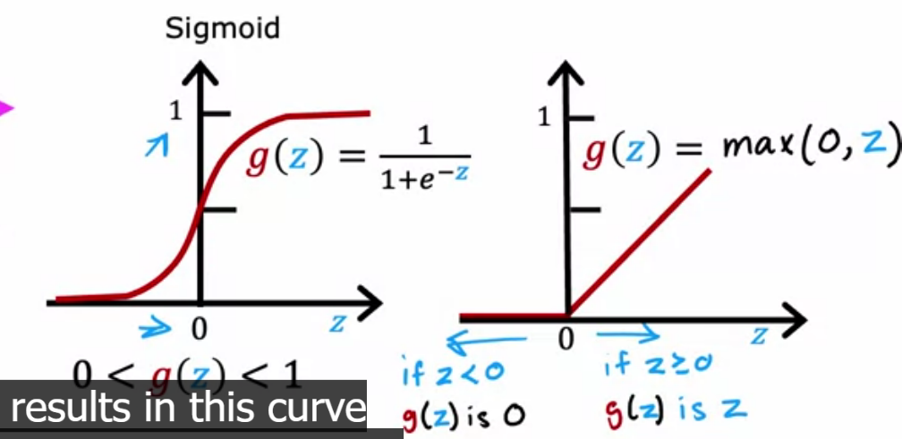



relU function allows the values of z to pass as long as it

is non-negative value.

relU stands for ( rectified linear Unit)

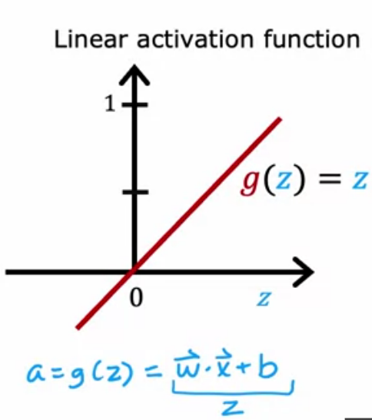

This means no activation function because

it doesn’t do

anything new to the original function

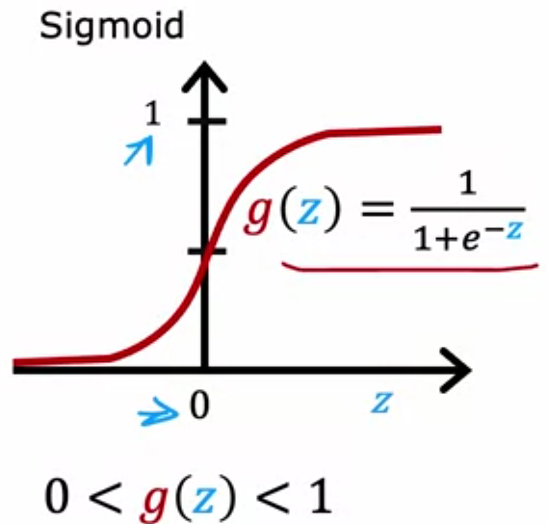

Choosing Activation function

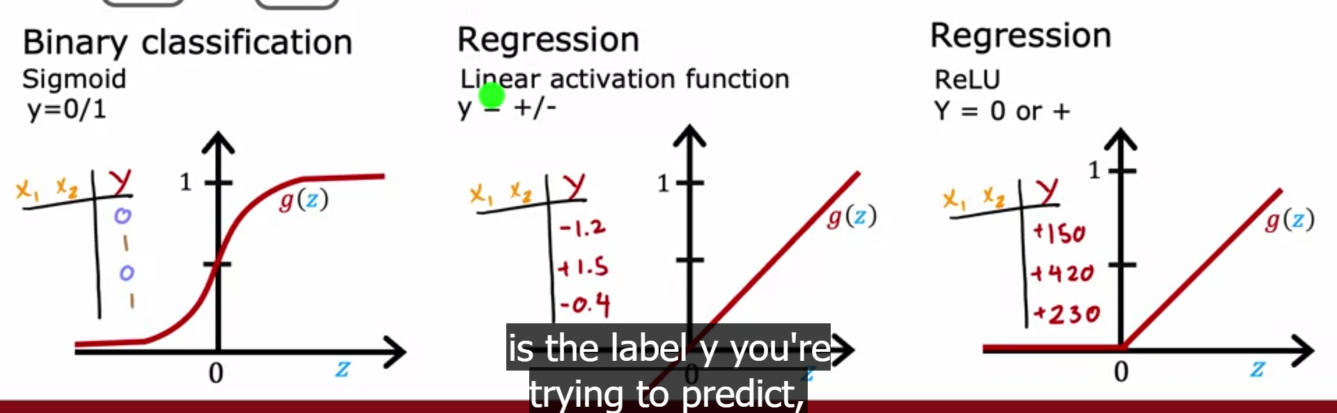

For a summary

Choose (relu) for the hidden layers, and for the output layer choose one of the three functions depending on the case of output.

___

Multiclass Classification

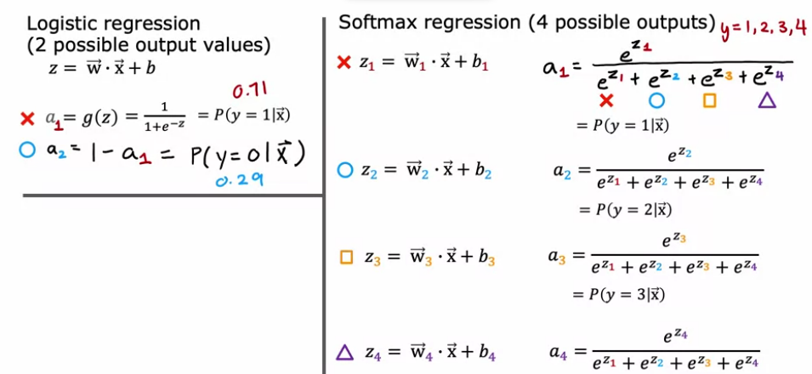Before the output was either 0 or 1 now we want to output more possible cases like 2, 3, 4 … 9

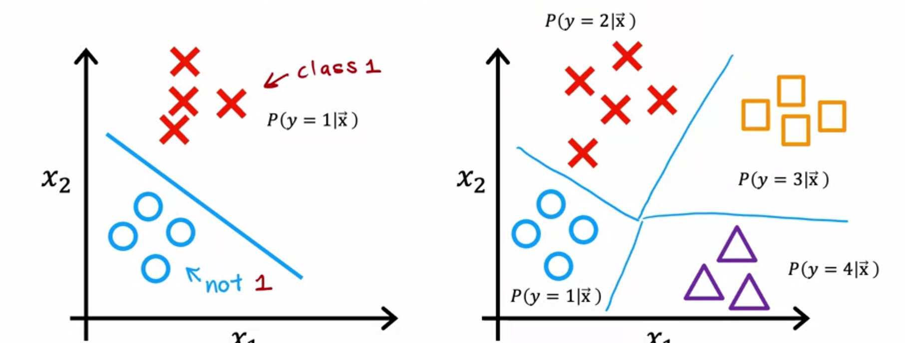

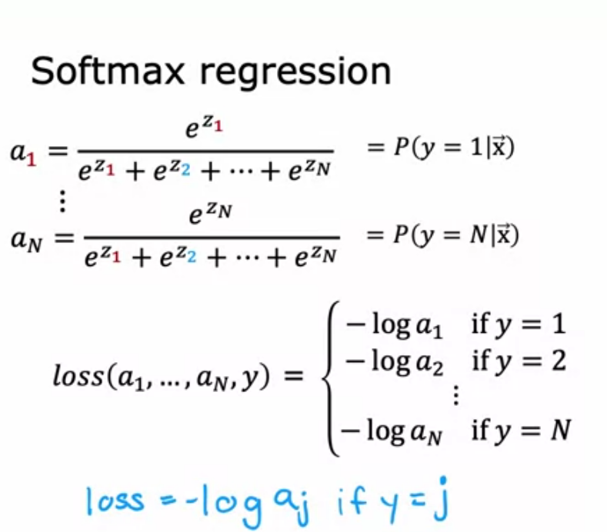

loss function of

softmax regreassion